#### ECE2610: Introduction to Signals and Systems

Lab 1: Introduction to MATLAB

uccs

Student Name

8/4/2010

## Introduction

The purpose of this lab is to provide an introduction to MATLAB. The exercises in the first two sections of the lab step through the basics of working in the MATLAB environment, including use of the help system, basic command syntax, complex numbers, array indexing, plotting, and the use of vectorization to avoid inefficient loops. The first two sections of the lab exercise are not covered in this report. The third section of the lab involves the use of MATLAB for the manipulation of sinusoids, and is the topic of this lab report.

## Manipulating Sinusoids with MATLAB

Three sinusoidal signals have been generated in MATLAB. The signals have a frequency of 4KHz, and have been generated over a duration of two periods. The first two signals, *x1(t)* and *x2(t),* are described by the following expressions

*x1(t)* = *A1* cos(2n(4000)(t - tm1))

#### x2(t) = *A2* cos(2n(4000)(t - tm2))

The amplitudes and time shifts are functions of your age and date of birth as described below.

*A1* = *my age* = 36



The time shifts are defined as

*tm1* =(*M*37.2) *T* = (3-7.-2) 250µsec = *1.3msec*

7

(1)

(2)

(3)

(4)

tm2 = - (*D*41.3) *T* = -

#### (41.3) 250µsec = -607.35µsec

where *M* = 7 is my birth month, *D* = 17 is my birth day, and *T* = 1/ *f* = *250µsec* is the period of the 4KHz sinusoidal signals.

17

The third sinusoid, *x3(t),* is simply the sum of *x1* (t) and x2 *(t).*

 (5)

The time vector, *t,* used to generate the signals has been generated with the following lines of MATLAB code.

f = 4e3;

T = 1/f;

tstep = T/25; t = -T:tstep:T;

% sinusoid freq

% period (250 usec)

% time step

% time vector

The time vector, *t,* ranges from - *T,* or one period prior to *t* = 0, to *T,* or one period after *t* = 0. The time step variable, *tstep,* controls the number of samples that are generated per period of the signal, in this case 25 points per period.

The signals defined by equations (1), (2), and (5) are plotted in Figure 1.

.

|  |  |  |  |  |  |  |  |  |  |  |  |
| --- | --- | --- | --- | --- | --- | --- | --- | --- | --- | --- | --- |
|  | -250 | -200 | -150 | -100 | -50 | 0 | 50 | 100 | 150 | 200 | 250 |
|  |  |  |  |  | **x2(t)** |  |  |  |  |  |
| -250 | -200 | -150 | -100 | -50 | 0  **x3(t)** | 50 | 100 | 150 | 200 | 250 |
| **M** .: |  |  |  |  |  |  |  |  |  |  |  |
|  | -250 | -200 | -150 | -100 | -50 | 0 | 50 | 100 | 150 | 200 | 250 |

time [µsec]

**Figure 1. Plots of the three sinusoidal signals generated in MATtAB.**

# Theoretical Calculations

The amplitudes and time shifts of the three sinusoids have been measured and annotated on the plot shown in Figure 2. The time shift values, *tmi,* can be used to calculate the phase of each signal as follows.

¢1 = *-T·*2rr = -

*tm1*

*78.6µsec 250µsec* · 2rr

= *-1.97radians*

(6)

¢ tm2 *-107.4µsec*

2 = --·*T*

2rr = -----·2rr = *2.7radians 250µsec*

(7)

Rewriting the expressions for x1 ( *t)* and x2 ( *t)* using the phase values calculated in (6) and (7) yields

*x1(t)* = 36cos(2rr(4000)t -1.97)

*x2(t)* = 43.2 cos(2rr(4000)t + 2.7)

(8)

(9)

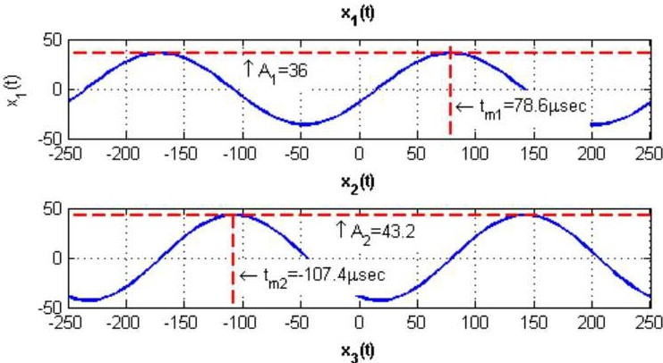

,,. ,

-:::,

N

X

-50

0 ·.. ··0··: ··....:. .. ·:· · · · _-:_· · · · · .\.·· · ··· · •....···: · · · · · · ·*:.***·t** :

:-·;

-1

-

J

s

: · · ·

-250 -200 -150 -100 -50

0

50

100 150 200

250

time [µsec]

**Figure 2. Thethree sinusoids with the amplitude and time shift of each annotated on the plot.**

Also shown in Figure 2 are the amplitude and time shift values for x3*(t).* These values were measured directly from the Figure 2 plot as A3 = 55 and tm3 = l *15µsec,* respectively. The time shift value can be used to calculate the phase of x3*(t)* as follows.

tm3 115µsec

¢ = --· *2n* = ----·*2*=*n-2.89radi.ans*

3

*T* 250µsec

### (10)

As an alternative to measuring the amplitude and phase of x3(t) graphically, the phasor addition theorem can be used to calculate these values. Expressed in complex exponential form, the first two sinusoids are



*x2(t)* = *Re{A2eNzeJwt}* = Re{43.2eJ2.7 ei2n:·4000t}

The third sinusoid, *x3(t),* can then be expressed as the sum of (11) and (12).

### (11)

(12)

(13)

Substituting in values for A1, *A2,* ¢1, and ¢2, and solving for A3 and ¢3 yields

 (14)

The calculated amplitude and phase values of A3 = 55.1 and ¢1 = -2.87 given in (14) agree very closely with the values obtained through graphical measurement. The phase values differ slightly due to the difficulty of identifying the exact time of the signal peak from the graph.

# Representation of Sinusoids with Complex Exponentials

Signals can alternatively be generated in MATLAB by using the complex amplitude representation. For example, the expression for *x1(t)* given in (11) can be used to generate the signal in MATLAB as shown in the following code segment.

Al= 36; % amplitude

phil = -1.975; % phase in radians xl = real(Al*exp(lj*phil).*exp(lj*2*pi*4000*t));

The signal resulting from these lines of code is plotted in Figure 3. Comparing Figure 3 to the top strip in Figure 1 clearly shows that *x1 (t)* generated using the complex amplitude representation is equivalent to

x1 *(t)* generated using the real-valued cosine function.

x1(t) Generated Using the Complex Amplitude Representation

60 ,

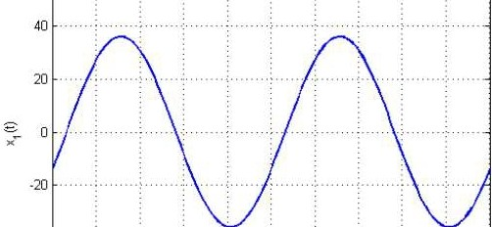

-40

**-60** ·······: ......,.......:.... *,,i,,,.*...;.....,,,!, ............i .......;....

-250 -200 -150 -100 -50 0 50 100 150 200 250

time [µsec[

Figure 3, Sinusoidal signal, *X1(t),* generated using the complex amplitude representation.

# Conclusion

This lab exercise has provided an introduction to the fundamentals of MATLAB. The third section of this lab, which has been detailed in this report, explored the use of MATLAB to generate sinusoidal signals. Three sinusoidal signals have been generated in MATLAB, the third of which was a sum of the other two. The phasor addition theorem has been employed to calculate the resulting amplitude and phase of the

summed signal. Additionally, it has been demonstrated that sinusoids can be equivalently generated in MATLAB using the complex exponential representation for those signals.

**Appendix A: MATLAB Code**

% labl 3.m

% ECE2610

% Lab 1

% Kyle Webb

% 8/4/10

clear all

f = 4e3;

T = 1/f; tstep = T/25;

t = -T:tstep:T;

Al = 36;

A2 = 1.2*Al;

**M** = 7;

D = 17;

tml (37.2/M)*T; tm2 = -(41.3/D)*T;

% sinusoid freq

% period (250 usec)

% time step

% time vector

% amplitude of xl (age)

% amplitude of x2

% birth month

% day of birth

% time shift for xl

% time shift for x2

% generate the sinusoidal signals xl Al*cos(2*pi*f*(t-tml));

x2 A2*cos(2*pi*f*(t-tm2)); x3 xl + x2;

Alt Al*ones(l,length(t)); A2t A2*ones(l,length(t));

% calculate time shifts for xl and x2 by subtracting excess periods

% from tml and tm2 tsl tml-5*T; ts2 = tm2+2*T;

% calculate phase (in radians) from the time shifts phil = -tsl/T*2*pi;

phi2 = -ts2/T*2*pi;

% and in degrees phil_deg phi1*180/pi; phi2_deg = phi2*180/pi;

% calculate the amplitude and phase of x3

using phasor addition

P3 = Al*exp(lj*phil)+A2*exp(lj*phi2); A3 = abs(P3);

phi3 angle(P3);

% phasor for x3

% amplitude of x3

% phase of x3

% plot the signals figure(l); elf subplot(311)

plot(t/le-6,xl,'LinewidLh',2); grid on ylabel('x_l(t)') title('x_l(t)','FontWeighL','Bold')

axis([-T/le-6 T/le-6 -50 50])

subplot(312)

plot(t/le-6,x2,'LinewidLh',2); grid on ylabel('x_2(L)') title('x_2(t)','FontWeighL','Bold') axis([-T/le-6 T/le-6 -50 50])

subplot(313)

plot(t/le-6,x3,'LinewidLh',2); grid on xlabel('Lime (\musec]'); ylabel('x_3(L)')

title('x_3(t)','FoncWeighc','Bold')

axis([-T/le-6 T/le-6 -65 65])

% plot the signals again, this time with annotations figure(2); elf

subplot(311)

plot(t/le-6,xl,'-b','LinewidLh',2); grid on; hold on plot(t/le-6,Alt,'--r','LinewidLh',2)

plot([tsl, tsl]/le-6,[-100, 100],'--r','Linewidth',2) ylabel('x_l(L)')

title('x_l(L)','FoncWeighc','Bold') axis([-T/le-6 T/le-6 -50 50])

text(tsl/le-6+5,-20,'\lefLarrow t_{m1}=78.6\musec',... 'HorizoncalAlignmenc','lef •,...

'BackgroundColor',[1 1 1])

text(-100,Al-20,'\uparrow A_1=36',... 'HorizoncalAlignmenc','lefL',...

'BackgroundColor',[1 1 1])

subplot(312)

plot(t/le-6,x2,'LinewidLh',2); grid on; hold on plot(t/le-6,A2t,'--r','Linewidth',2)

plot([ts2, ts2]/le-6,[-100, 100],'--r','Linewidth',2) ylabel('x_2(c)')

title('x_2(t)','FontWeight','Bold')

axis([-T/le-6 T/le-6 -50 50))

text(ts2/le-6+5,-20,'\lefcarrow c_{m2}=-107.4\musec',... 'HorizoncalAlignment','lefc',...

'BackgroundColor',[1 1 1])

text(-20,A2-20,'\uparrow A_2=43.2',... 'Hori2oncalAlignment','lefc',...

'BackgroundColor',[1 1 1])

subplot(313)

plot(t/le-6,x3,'Linewidch',2); grid on

xlabel('cime (\musec]'); ylabel('x_3(c)'); hold on plot([-T/le-6, T/le-6],[55, 55],'--r','Linewidth' ,2)

plot([115, 115],[-100, 100],'--r','Linewidth',2)

title('x_3(L)','FonLWeighL','Bold') axis([-T/le-6 T/le-6 -65 65])

text(115+5,-20,'\lefcarrow {m3}=115\musec',... 'HorizoncalAlignmenc','lefc',...

'BackgroundColor',[1 1 1]) text(-40,55-25,'\uparrow A_3=55',...

'HorizonLalAlignmenc','lef •,...

'BackgroundColor',[1 1 1))

Al= 36; % amplitude

phil = -1.975; % phase in radians xl = real(Al*exp(lj*phil).*exp(lj*2*pi*4000*t));

figure(3); elf

plot(t/le-6,xl,'-b','LineWidLh',2); grid on

xlabel('Lime (\musec]'); ylabel('x_l(t.) ')

title('x_l(t) Generat.ed Using t.he Complex Amplitude Represen at.ion'...

,'Font.Weight.','Bold')

axis([-T/le-6 T/le-6 -65 65))